Granny Smith  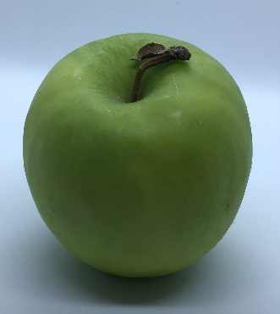  Size: medium to large and round  Country of origin: Australia  Colour: bright green skin often speckled with faint spots  Taste: firm and juicy with a thick skin and acidic/sweet flavour  Good for: baking, salads  Availability: all year round  Nutritional value: high in antioxidants, good source of soluble fibre, vitamins A and C  Interesting fact: Granny Smith is one of the first varieties of apple widely available in supermarkets as they have thick skins and are great for storing qualities. | Golden Delicious  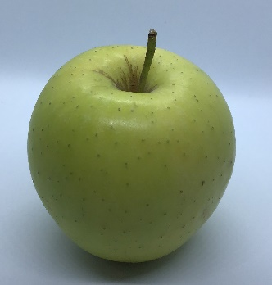  Size: small to medium in size, and oblong in shape  Country of origin: USA  Colour: pale green to golden yellow, speckled with small spots.  Taste: firm, crisp, aromatic flavour  Good for: dessert, pureeing, baking, juicing and drying  Availability: autumn through to summer  Nutritional value: low in calories, good source of soluble fibre, contain vitamins A and C  Interesting fact: Golden Delicious is a parent apple to well-known varieties such as Gala and Pink Lady. | Braeburn  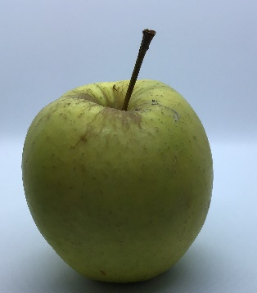  Size: medium to large, oval in shape  Country of origin: New Zealand  Colour: thin skin, yellow and is covered with pink and red stripes  Taste: crisp and juicy, with sweet subtle hints of spice, nutmeg and cinnamon  Good for: eating raw, baking, roasting, pureeing  Availability: late autumn to early spring  Nutritional value: good source of fibre, vitamins A and C  Interesting fact: The striping varies depending on the climate. It is created by nature.

Gala  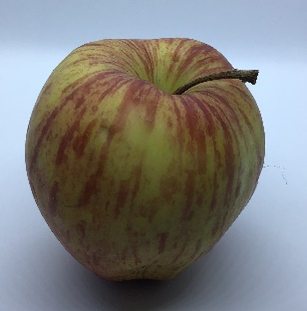  Size: medium  Country of origin: New Zealand  Colour: yellow to orange skin, highlighted with pink to red stripes  Taste: crisp, with sweet flavour and floral aroma  Good for: snacking, salads and chutneys  Availability: all year round  Nutritional value: low in calories, vitamins A, C and B, also fibre and trace amounts of boron  Interesting fact: Gala apples grow well in warm and cold climates. | Cameo  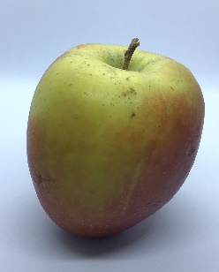  Size: small to medium  Country of origin Kent, England  Colour: varies from red to pale green/orange  Taste: bland with a hint of pear  Good for: eating  Availability: late summer/autumn  Nutritional value: low in calories, high in fibre  Interesting fact: The Cameo apple is considered a new apple variety. | Pink Lady  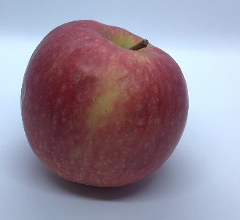  Size: medium to large  Country of origin: France  Colour: pink/blush colour  Taste: crisp, sweet and juicy  Good for: eating  Availability: needs a long warm season to mature  Nutritional value: high in vitamins  Interesting fact: Pink Lady is the trade name. It is actually a Cripps Pink apple.

Red Chief  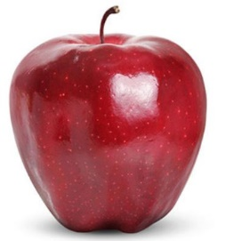  Size: small  Country of origin: Spain  Colour: deep red  Taste: firm, crunchy and scented  Good for: cooking or eating raw  Availability: all year  Nutritional value: good for vitamins  Interesting fact: The Red Chief apple oxidises really quickly. It is originally from Chile. | Fuji  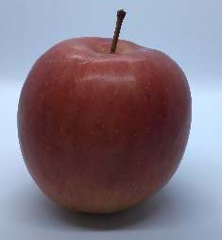  Size: large to very large, 75mm  Country of origin: Spain  Colour: pink flecks over yellow green skin  Taste: sweet, crisp and juicy  Good for: good all-rounder  Availability: all year  Nutritional value: good for fibre and vitamins  Interesting fact: The Fuji apple is originally from Japan. | Red Delicious  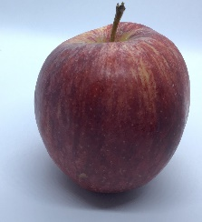  Size: large heart-shaped  Country of origin: USA  Colour: deep red, and speckled  Taste: crisp/ dense, with a sweet and floral aroma  Availability: all year round  Nutritional value: small amount of vitamin A and C, higher in antioxidants than many other apples  Interesting fact: Their flavour goes well with cinnamon, cheddar cheese, chard, cherries, and mustard.

