Cut out and rearrange the photographs and statements to show the life cycle of an apple tree.

In the Winter the tree loses all its fruit and leaves.

In the Spring, blossom forms on the branches, often before the leaves.

The flowers are pollinated by insects.

Towards the summer, flowers lose their petals and the fruit begins to grow.

During the Summer and early Autumn fruit gradually gets bigger.

In late Summer / early Autumn the fruit is nearly ready to pick.

In the Autumn the fruit is ready to pick.

In the Spring the blossom and the leaves cover the branches of the tree.

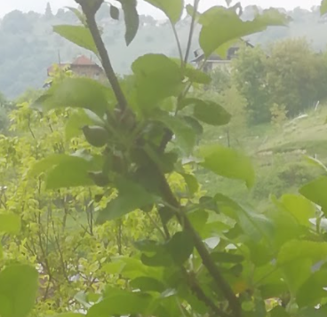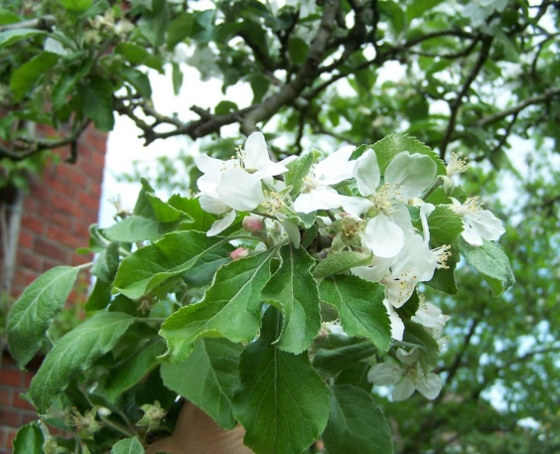
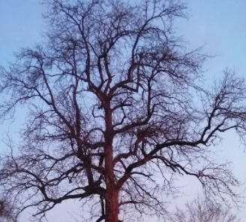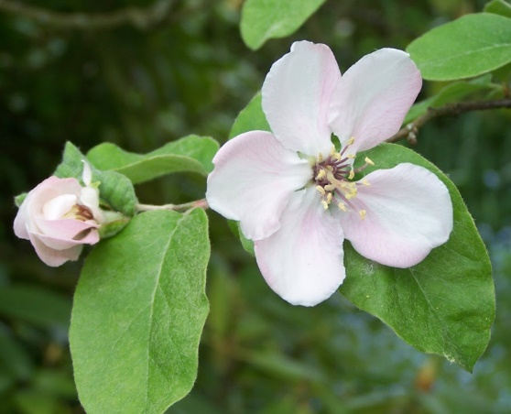

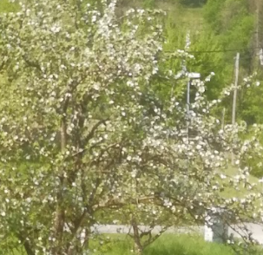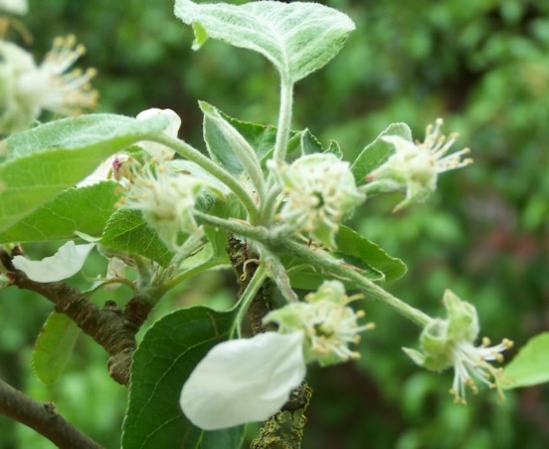

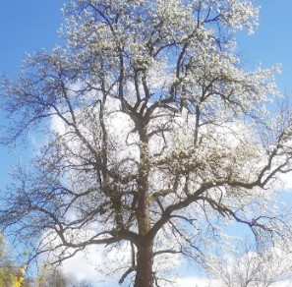

Photographs by Renata Flander and Dagmar Isheim

