Where do the apples that are offered in your local store or supermarket originally come from?

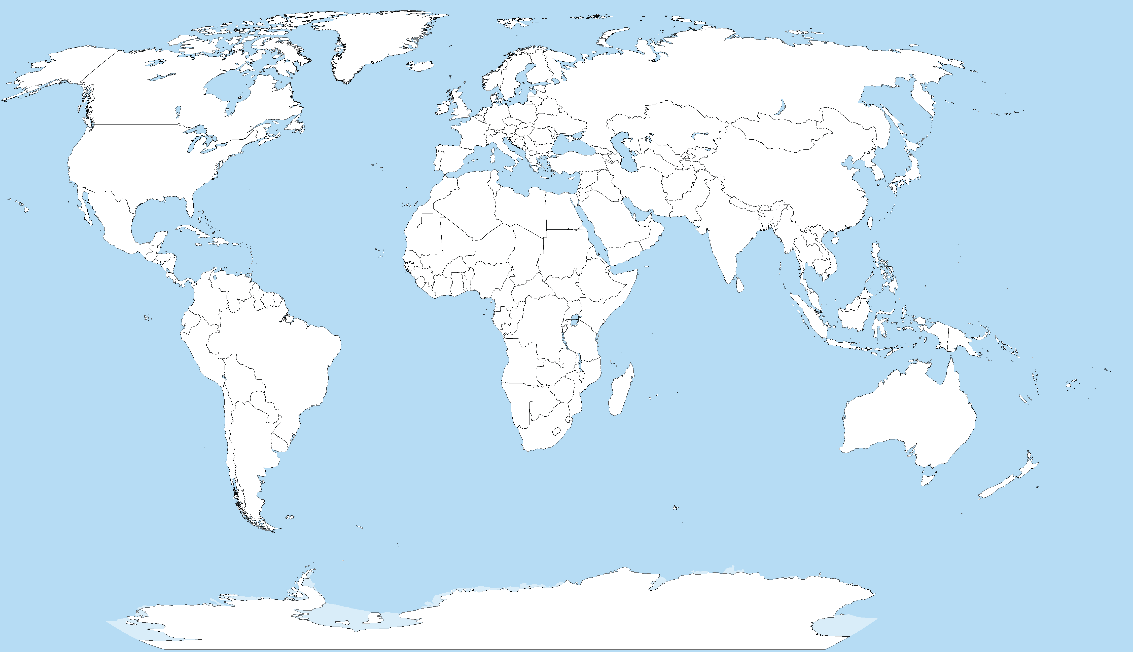

Picture: Petr Dlouhý, Public domain, via Wikimedia Commons, https://upload.wikimedia.org/wikipedia/commons/6/63/A_large_blank_world_map_with_oceans_marked_in_blue.svg

