If you want to put your product on the market you will need A PRODUCT LABEL with all the information that is demanded by law. People buy products because of how they look so make sure that the label is also attractive.
An Apple a Day Keeps the Climate Okay

Make a label for your vinegar

Home made vinegar
SonS
Produced by Science on Stage Germany
Use as much as you want, if it is too sour add water.

Store in dry place at room temperature.
Unlimited expiration date

Bio SDG label 0.2l
Name of the product:
Trademark:
Producer:
Best before:
Instruction for use:
Conditions to store:
Quantity:
Quality label:

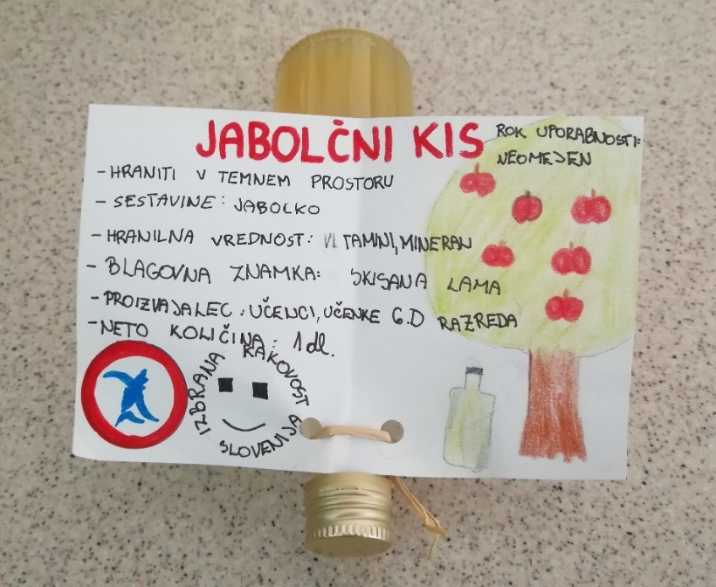

Photograph by Renata Flander

