Making your own vinegar
An Apple a day Keeps the Climate Okay

Apple Vinegar
Do you have too many apples in the garden and don't know what to do with them? Even though you like them as a fresh snack or a very popular apple pie, are you still afraid that they will rot? What about making a vinegar?
Ingredients:
- 500 g organic apples
(to avoid the chemicals in the apple skin and make healthy vinegar)
- 2 tablespoon sugar
- 1 l water
- 1 tablespoon vinegar
Equipment:
Pot (1 l), tablespoon, 1 large jar (2.5 l), paper towels, grater, household clingfilm, strainer, jug, 2 small jars (1 l), gauze, scissors, 2 elastics bands, funnel, small vinegar bottle (0.2 l)
1st day:
- Boil 1 l of water (to kill the undesirable microorganisms) in the pot for at least 3 minutes, add two tablespoons of sugar (in hot water it will dissolve very quickly) and cool to room temperature.
- Grate 500 g apples so that the sugar from the apples can go into the water.
- Add them into the big jar and pour the solution with the sugar over the apples.
- Cover the jar with clingfilm and tighten with elastic band.
- Leave at room temperature.

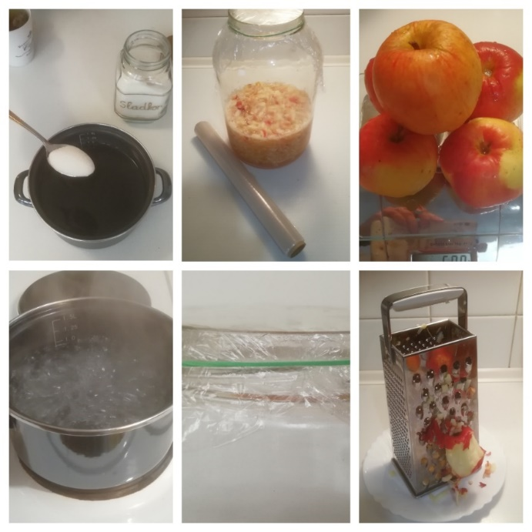

After 3 weeks
- Strain the contents of the jar into two smaller jars.
- Add one tablespoon of vinegar (cultures of microorganisms) into one jar.
- Cover the jars with a gauze to avoid dust and insects.
- Tighten with an elastic band and leave at room temperature.

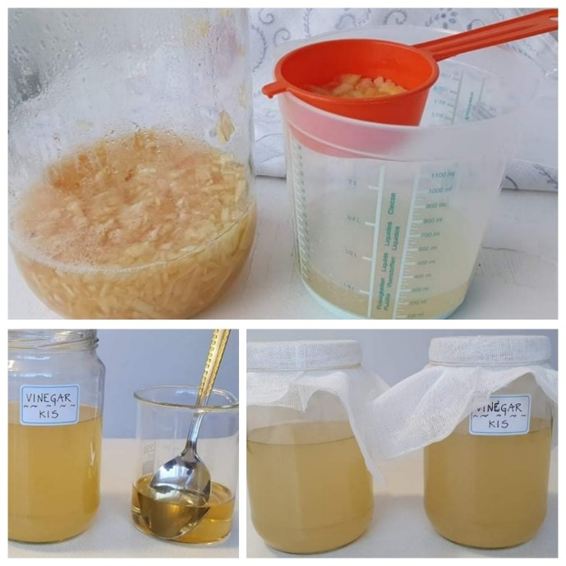

After 6 weeks
- Separate the vinegar from the sediment and pour it into bottles.
- Compare the results. The process is faster when you add some micro-organisms.

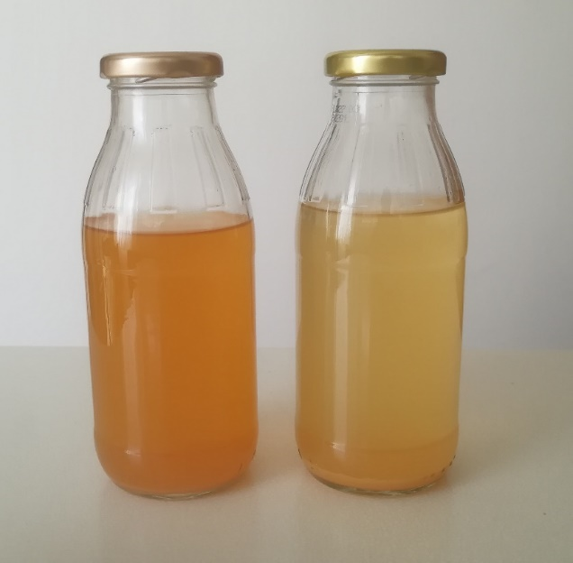

Observe the process every day. Write a diary about the changes. Draw or take a picture about the changes.
Date/day | Picture | Describe the changes
1st day | 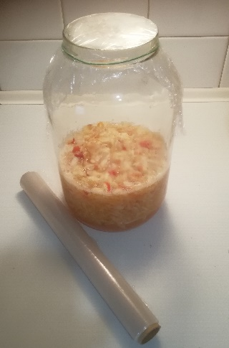 | Prepare everything to make a vinegar.

