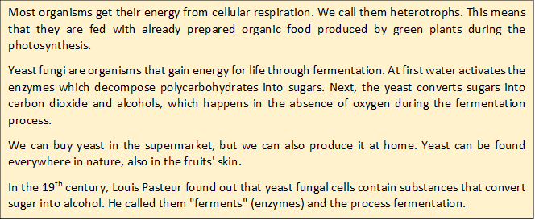
An Apple a Day Keeps the Climate Okay

Apple Usage: Apple Yeast
- Look for a recipe for apple yeast on the internet. Use key words “APPLE YEAST”.
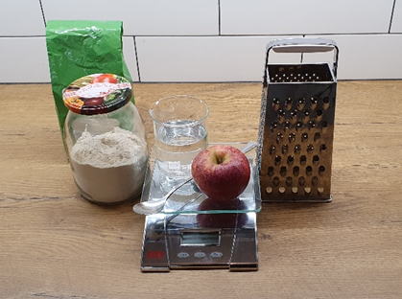
For example:
Ingredients:
- 250 g flour
- 200 mL water
- 1 tablespoon sugar
- 1 small, grated apple
Equipment:
Kitchen scales, beaker or a glass with a scale, 1 litre jar with lid, tablespoon, grater, plate
Preparation:
Mix all the ingredients in a 1 litre jar. Close the jar with a cover and leave at room temperature.
After 3–5 days the jar will be full. Next, add 200 g of flour and knead the dough for your pizza.

Does the recipe you found on the internet have a scientific basis?

Plan an investigation to find out.

- QUESTION:
Does the mixture rise, if we don't add ________________________________ (e.g. apple …)?

- HYPOTHESIS: (Read about fermentation and write the hypothesis)
The mixture will/will not rise, because ____________________________________________

- EXPERIMENT:
For investigation use the internet recipe but prepare smaller amounts:
Ingredients:
- 50 g flour
- 40 g water
- 1 teaspoon sugar
- 1 tablespoon grated apple

Equipment:
Kitchen scales, 200 ml jar with lid, tablespoon, teaspoon, grater, elastic bands in different colours
- Form a group with the other students who have the same hypothesis as you. Each group prepares a sample with one ingredient missing and one control sample with all the ingredients in the recipe.
If you want to measure the height of the mixture, mark the height with an elastic band. If you want to measure it every day, use differently coloured elastic bands.
 | Flour | Water | Sugar | Room temperature | Apple | Does the mixture rise? | Height of the mixture
All groups | + | + | + | + | +
Group 1 | + | + | + | + | -
Group 2 | + | + | + | - | +
Group 3 | + | + | - | + | +
Group 4 | + | - | + | + | +

Think about the VARIABLES AND CONSTANTS.
INDEPENDANT VARIABLE (factor to be changed) ___________________________________________
DEPENDANT VARIABLE (result to be measured) ____________________________________________
CONSTANTS (factor to keep the same) __________________________________________________________________________________
- RESULTS:
Table title: __________________________________________________________________
 | Flour | Water | Sugar | Room temperature | Apple | Does the mixture rise? | Height of the mixture
Jar 1
Jar 2

Graph title: _________________________________________________________________________
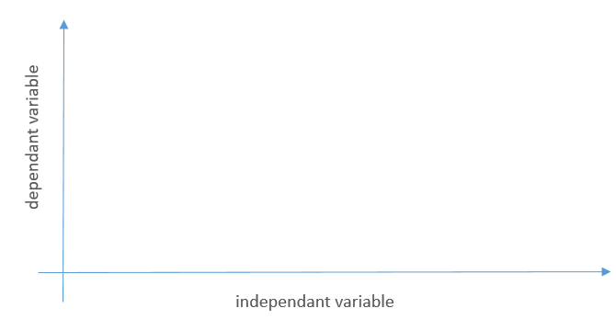

- DISCUSSION:

Confirm or deny the hypothesis.
___________________________________________________________________________
Try to explain with scientific ideas.
______________________________________________________________________________________________________________________________________________________
Explain the connection with a real-life example.
________________________________________________________________________________________________________________________________________________________________
Did any new ideas come to mind while doing the experiments? Possibly more than one? What are they? Try to explain as fully as possible.
________________________________________________________________________________________________________________________________________________________________

