Materials
CO2MUCH – Think Global, Act Local

Solar water electrolysis using a hydrogen fuel cell
- Solar fuel cell kit
- 400W lamp or sun
- Voltmeter
- Ammeter

Protocol
- To assemble the fuel cell and the solar cell, follow the instructions that came with your solar fuel cell kit.
- Measure the voltage, current, gas volume every 30 s.
- Calculate the energy consumption.

At the anode (the positive pole)
Water reacts to form oxygen (O2) and hydrogen ions H+ and electrons e-. The hydrogen ions H+ pass through the proton exchange membrane (pem) to the cathode. The e- are blocked by the pem and travel through the electrical circuit.

At the cathode (the negative pole)
Hydrogen ions H+ and electrons e- coming from the electrical circuit recombine to form hydrogen (H2).
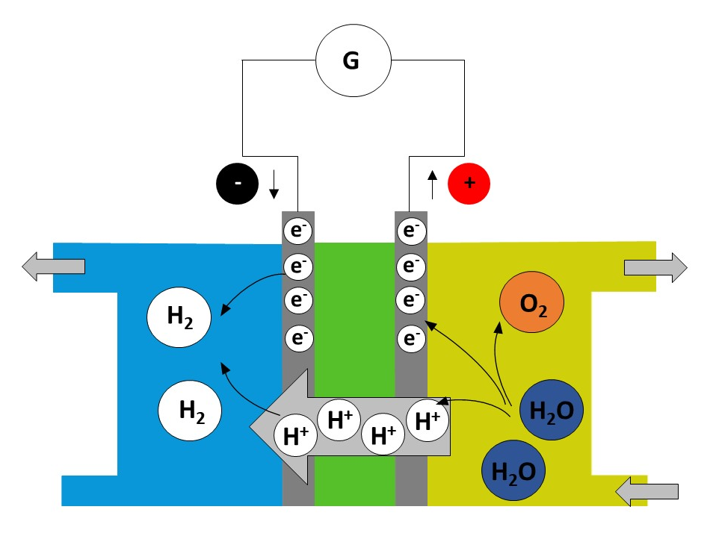

Tasks
The reaction observed is an electrochemical reaction, involving the following two redox couples:
H+(aq)/H2 (g) and O2(g)/H2O(l).

- Write down the half-equation at the anode.
Specify whether there is oxidation or reduction.

- Write down the half-equation at the cathode.
Specify whether there is oxidation or reduction.

- Write the balance equation for the reaction used to operate the fuel cell.

- Calculate the energy consumption.

