1. CO2 emissions from the transport sector
CO2MUCH – Think Global, Act Local

Hydrogen, a fuel for the future?
CO2 emissions from the global transport sector reached nearly 8.5 Gt in 2019. The "zero net emissions by 2050" scenario requires that transport sector emissions decline by 20% to 5.7 Gt in 2030. This decline will depend on policies to encourage modal shifts to less carbon-intensive travel options, as well as operational and technical energy efficiency measures to reduce the carbon intensity of all modes of transport. Policies that promote the blending of true low-carbon fuels are critical to decarbonizing aviation, shipping, and heavy road freight.
Source: International Energy Agency, https://www.iea.org/topics/transport
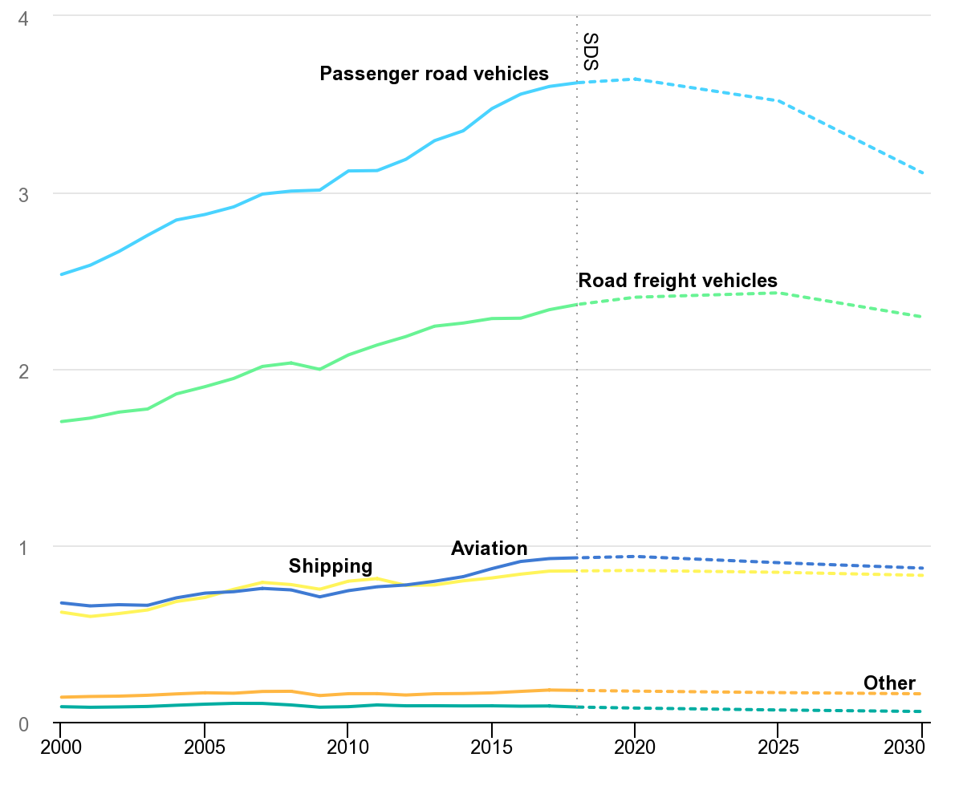
IEA, Transport sector CO2 emissions by mode in the Sustainable Development Scenario, 2000-2030, IEA, Paris https://www.iea.org/data-and-statistics/charts/transport-sector-co2-emissions-by-mode-in-the-sustainable-development-scenario-2000-2030

Tasks
- What type of transportation produces CO2?
- Estimate the mass of carbon dioxide emitted by passenger road vehicles in 2020.
- Calculate the mass of carbon dioxide emitted by passenger road vehicles that is set to be produced in 2050.
- Comment the «Zero net emission» expression.

2. The hydrogen car
It is very common to hear about hydrogen engines, hydrogen fuel cells and hydrogen cars. Hydrogen is used in the form of dihydrogen (H2).
A fuel cell stores the chemical energy of hydrogen combined with oxygen from the air. This chemical energy is converted and transferred into thermal energy and electrical energy used in hydrogen electric vehicles, where the hydrogen is combined with oxygen from the air.
In both cases the chemical transformation produces only water.

Tasks
- Identify the reactants and the product of the chemical transformation in hydrogen fuel cells.
- Write the balanced equation of the transformation.
- Complete the energy diagram with the correct energy form.

3. Production of hydrogen
Hydrogen does not exist in its natural state. It must be produced from hydrocarbons or water, which first requires an expenditure of energy. Hydrogen is mainly produced from fossil energy resources.

Fossil-based hydrogen - Creating hydrogen from hydrocarbons
The reforming of methane from natural gas is currently the main source of hydrogen. The reaction of methane with water at high temperature requires a lot of energy. It produces a mixture of carbon monoxide, carbon dioxide and hydrogen.

Green hydrogen - How can hydrogen by created using water electrolysis?
The passage of a direct current through water leads to its breakdown and the creation of hydrogen and oxygen: this is called water electrolysis. The breakdown of water is given by the following balanced equation:
2 H2O → 2 H2 + O2

Tasks
- Find the correctly balanced balance equation representing the methane reforming process and explain your choice.
CH4 + H2O → CO2 + H2
CH4 + H2O → CO2 + 3 H2
CH4 + 2 H2O → CO2 + 4 H2
- Balance the equation of water electrolysis.

4. Comparison of the two types of hydrogen production
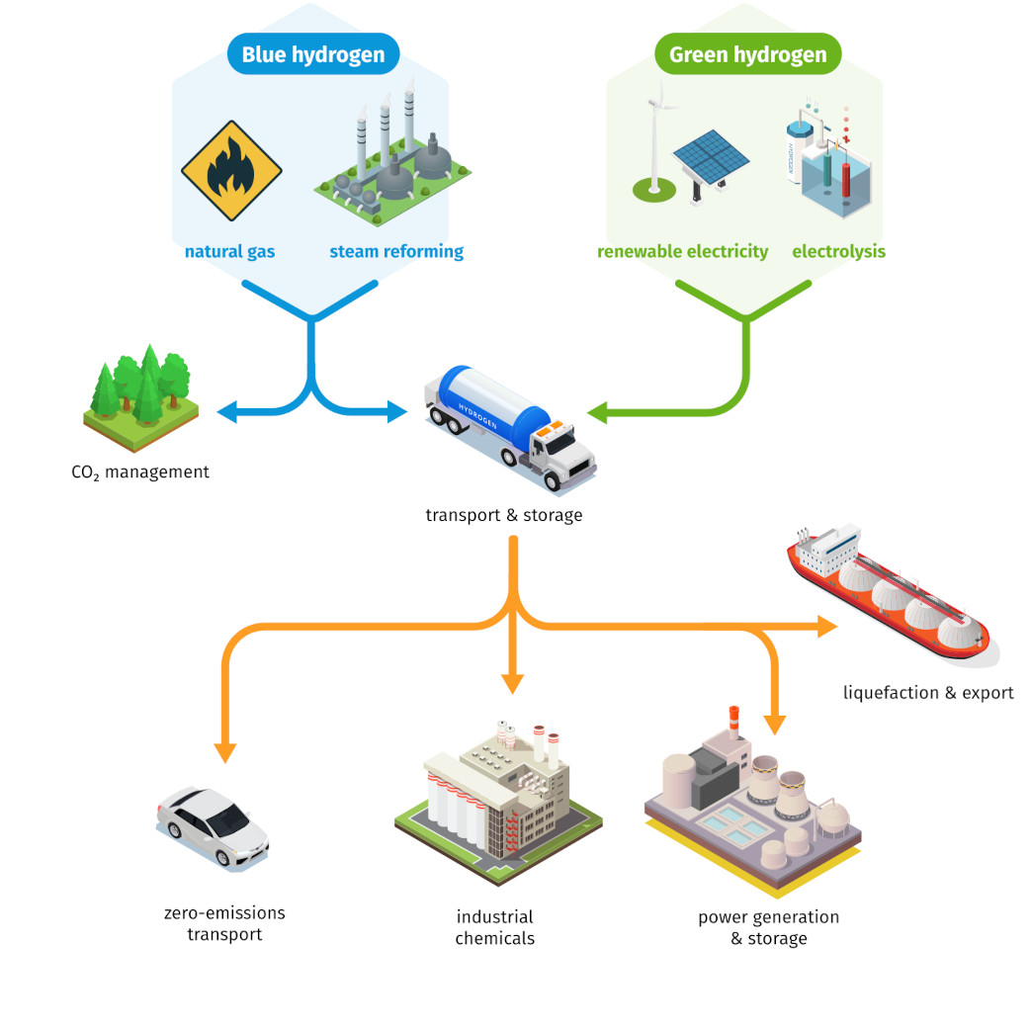

5. Questions related to all texts
- List the environmental advantages and disadvantages of using a vehicle powered by a hydrogen fuel cell.
- Under what conditions can fuel cells be considered "green" from an environmental point of view?

