At the anode (the negative pole)
CO2MUCH – Think Global, Act Local

Working principle of a hydrogen fuel cell
Pressurised hydrogen gas (H2) with the platinum catalyst splits into hydrogen ions H+ and electrons e-.
The hydrogen ions H+ pass through the proton exchange membrane (pem) to the cathode.
The e- are blocked by the pem and travel through the electrical circuit to the cathode providing an electrical current.

At the cathode (the positive pole)
Oxygen (O2) (pure or coming from the air), hydrogen ions H+ and electrons e- (coming from the anode) recombine to form water molecules.

Tasks
1. Label the fuel cell model to make the cell work.
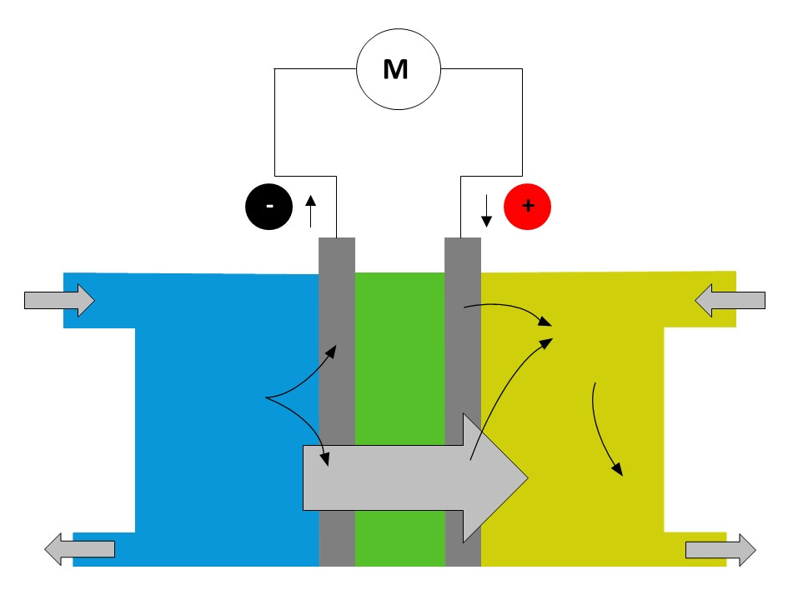

The reaction observed is an electrochemical reaction, involving the following two redox couples:
H+(aq)/H2 (g) and O2(g)/H2O(l).
2. At the cathode, the positive pole of the cell, the oxidant involved is the oxygen of the pair O2 (g)/H2O (l).
Write down the half-equation at the cathode.
Specify whether there is oxidation or reduction.

3. At the anode, the negative pole of the cell, the reductant used is the hydrogen H2 of the pair H+ (aq) / H2 (g).
Write down the half-equation at the anode.
Specify whether there is oxidation or reduction.

4. Write the balanced equation for the reaction used to operate the fuel cell.

5. What material is recovered at the cathode?

