German scientists compared apples grown in Germany and stored for 5 months in cold atmosphere (CA) to freshly harvested apples from New Zealand. They only looked at energy costs for transportation from the apple farms to the home consumer (see Figure 1).
An Apple a Day Keeps the Climate Okay

Locally grown apples in Europe versus apples from overseas
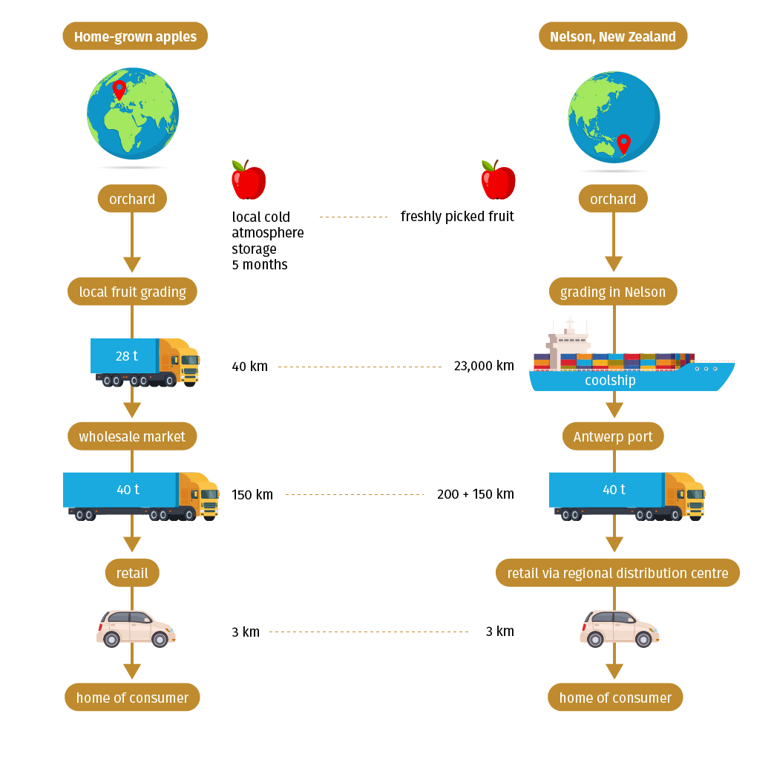
Figure 1: Transport channels of the food supply chain to compare primary energy requirements of locally grown apples in Germany stored for 5 months versus freshly harvested apples imported from New Zealand in April.
CA- cold atmosphere, RDC- regional distribution centre
Source: M. Blanke; B. Burdick (2005): Food (miles) for Thought, ESPR12(3) 125-127 (modified)

Talking about sustainability includes more than just arguing based on one indicator. Aspects of climate impact or environmental impacts as for example noise and air pollution during transportation, land consumption and fragmentation of the landscape are not considered. However even “just” looking at energy costs is already quite impressive...

Work assignment
1) Calculate the total amount of energy costs for home -grown and imported apples!
2) Analyse the table and compare the energy costs for both apples (local and imported)!

Home-grown, local fruit  from Germany | Primary energy requirement  [MJ/kg apples] | Import from New Zealand | Primary energy requirement  [MJ/kg apples]
Apple cultivation | 2.800 | Apple cultivation | 2.100
Initial cooling after harvest | 0.086 | Initial cooling after harvest | 0.086
150 days CA storage at 1 °C in Germany | 0.810 | 23.000 km in refrigerated on a ship from New Zealand to port of Antwerp,  28 days cooling on board | 2.534  0.302
Packaging | 0.650 | Packaging | 0.650
Transportation to regional distribution centre in a small truck, 40 km | 0.093 | Transportation to regional distribution centre in a large truck, 200 km | 0.276
Transportation to retail (supermarkets) in a big truck, 150 km | 0.207 | Transportation to retail (supermarkets) in a big truck, 150 km | 0.207
Cooling on truck 95 km * | 0.028 | Cooling on truck 175 km * | 0.055
Consumer shopping by private car, 6 km | 1.150 | Consumer shopping by private car, 6km | 1.150
Total amount |  | Total amount

Table 1: “Food miles” - primary energy requirements per kg apples in April
* It is assumed that half the distance of transportation is done in a cooling truck.
source: M. Blanke; B. Burdick (2005): Food (miles) for Thought, ESPR12(3) 125-127 (modified and simplified)

