Interference of waves – short summary
Consider a float on a surface of the lake, which goes up and down. Due to the vertical motion of the float, the waves start propagating along the surface of water: The float is the source of the waves.
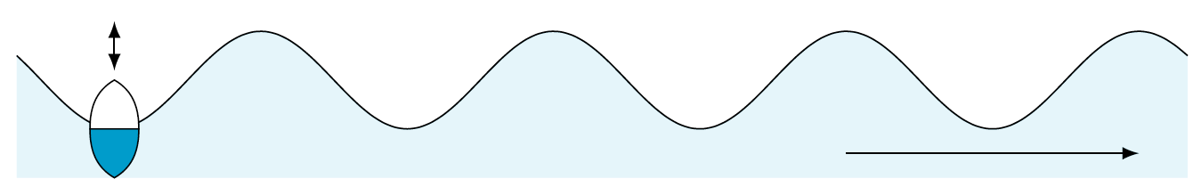
Suppose now that there are two floats on the lake, and each of them is producing waves. The water level at any point on the surface will then be affected by waves coming from both floats: We can say that the waves add up or superimpose. As a result, the water level at the given point will oscillate with a certain amplitude, which depends not only on the amplitude of oscillation of each float, but also on the relative distance between the floats.
Consider a point P at which the two waves arrive in the same phase, i. e. water oscillations at P due to both waves separately would peak at exactly the same time (figures on the left). The ‘effect’ of one wave will be enhanced by the ‘effect’ of the other, and the resulting water oscillations at P will happen at a greater amplitude. It is said that two waves interfere constructively at point P.
On the other hand, if the distance between the sources and the point P is changed, it may happen that the two waves will arrive at P in counter phase, i. e. water oscillations at P due to one wave will reach maximum at exactly the same moment as oscillations due to the other wave will reach minimum (figures on the right). The ‘effect’ of one wave will be cancelled by the ‘effect’ of the other, so the water will not oscillate at all at P. It is said that two waves interfere destructively at point P.
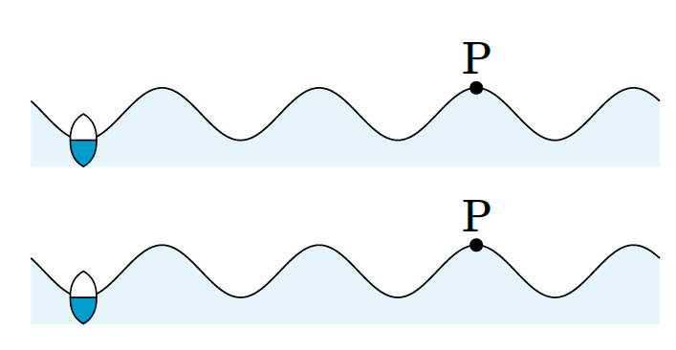
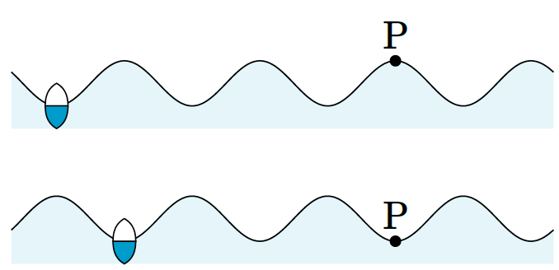
oscillations at P: oscillations at P:

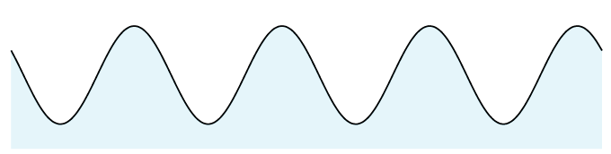

The same idea applies to any kind of waves: sound, light and even matter waves.

