Worksheet: Modelling Quantum Entanglement using LEDs
In this activity entangled quantum objects have the opposite state for each measurement. Every time you press button A on your micro:bit, you are measuring the “quantum objects”, which in your micro:bit are represented by each LED.

Your task
Do you think you can identify the two quantum objects that are entangled?
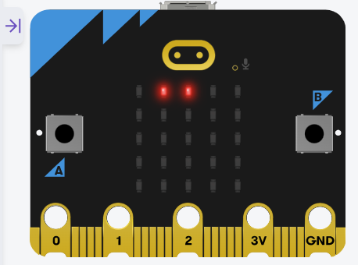
For this activity, we are considering that two “quantum objects” are entangled if when we measure one of them and is ON, the entangled one is OFF and the other way around.

Instructions
- Press button A on your micro:bit
- Record the outcome in the table below and wait 2 seconds.
- Repeat steps 1 and 2 as many times as needed

Measurements
Complete the table below to record your measurements (0/1 or ON/OFF)
 | LED 0 | LED 1 | LED 2 | LED 3 | LED 4
Measurement 1
Measurement 2
Measurement 3
Measurement 4

Select the numbers corresponding to the two quantum objects (LEDs) that you think are entangled: __________________
Explain why you have selected those two quantum objects as the entangled ones.

