The supremacy of quantum algorithms

Lesson 2– The Bernstein-Vazirani Algorithm

Testing the algorithm for the Case $n=2$
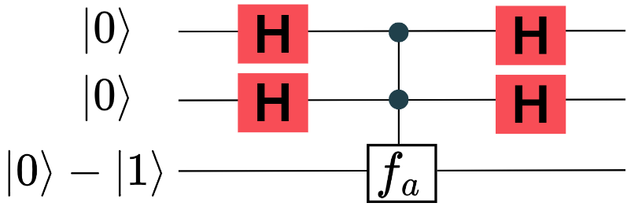
Now, you will analyze each step of the algorithm to understand how the quantum principles behind it allow us to solve the problem with a single query for the case $n=2$. Here is the circuit for this case:

Task 1
Step I: Show that after applying a Hadamard gate to each $|0⟩$ in the first register, the first register transforms into:
$$H\left|0\right\rangle H\left|0\right\rangle =\frac{1}{2}(\left|00\right\rangle +\left|01\right\rangle +\left|10\right\rangle +\left|11\right\rangle )$$
Hint: The Hadamard operator can be expressed as $H=\frac{1}{\sqrt{2}} ( |0⟩⟨0|+|0⟩⟨1| +|1⟩⟨0|-|1⟩⟨1|)$.

Task 2
Step II: We know that applying the function $f_{a}$ to the state obtained in Step I results in the following transformation:
$$\frac{1}{2}\left[{ \left(-1\right)}^{f_{a}\left(00\right)}\left|00\right\rangle +{\left(-1\right)}^{f_{a}\left(01\right)}\left|01\right\rangle +{\left(-1\right)}^{f_{a}\left(10\right)}\left|10\right\rangle +{\left(-1\right)}^{f_{a}\left(11\right)}\left|11\right\rangle \right]$$
Note: The function $f_{a}​$ introduces phase shifts in the first register without directly affecting the second register. This is a fundamental concept in quantum computing. If you would like to explore in detail how and why these phase shifts occur, go to the Quantum Function Evaluation worksheet.
Your tasks
- Assume that $a=(1,0)$ and determine the function values by filling in the following table:

Input $x$ | $$a⋅x=a_{1}⋅x_{1}+ a_{2}⋅x_{2}$$ | Odd | Even | Output $f_{a}\left(x\right)$
$$\left(0, 0\right)$$
$$\left(0, 1\right)$$
$$\left(1, 0\right)$$
$$\left(1, 1\right)$$

- Show that applying $f_{a}$ transforms the state from Step I as follows:
$$\frac{1}{2}\left[\left|00\right\rangle +\left|01\right\rangle -\left|10\right\rangle -\left|11\right\rangle \right]$$

Hint: The values in your table determine the signs of each basis state.

Task 3
- Step III: Apply a Hadamard gate to each qubit in the state obtained in Step II:
$$\frac{1}{2}\left[\left|00\right\rangle +\left|01\right\rangle -\left|10\right\rangle -\left|11\right\rangle \right]$$
Show that this transformation exactly results in $\left|10\right\rangle .$
Hint 1: Use the Hadamard transformations:
$H|0⟩=\frac{1}{\sqrt{2}} ( |0⟩ +|1⟩)$, $H|1⟩=\frac{1}{\sqrt{2}} ( |0⟩ -|1⟩)$.
Hint 2: For example, applying Hadamard gates to $|0⟩$ and $|1⟩$ separately:
$H|0⟩ H|1⟩=\frac{1}{\sqrt{2}} ( |0⟩ +|1⟩)$ $\frac{1}{\sqrt{2}} ( |0⟩ -|1⟩)$.

- What do you obtain after measuring the first register?
- Compare your result with $a=\left(1,0\right).$
- What does this tell you about the problem that the algorithm is designed to solve?

- Scaling to $n=3$: Suppose you want to test the algorithm for $n = 3.$
- How many terms would you obtain in Task 3 a) before cancellation of equal terms?
- Explain why your teacher asked you to test the algorithm only for $n=2$ and not for $n=3$.

Task 4

If you still have time and motivation, repeat Steps I, II, and III for the remaining binary strings:

$$a=(0,0), a=(0,1), a=(1,1).$$

Optional Task: Implementing the Bernstein-Vazirani Algorithm in the IBM Quantum Composer
In this task, you will implement the Bernstein-Vazirani algorithm using the IBM Quantum Composer. The circuit in the image represents the implementation of the algorithm for n = 2. Analyze it carefully and answer the following questions:
a) The first two Hadamard gates are applied to the first two qubits. What is their purpose? How does their effect relate to the superposition state you calculated in Task 1?
b) There is an X-gate applied at the beginning to the output qubit. Why is this necessary? Predict what would happen if the X-gate were missing and then test your prediction in the Quantum Composer.
c) The last two Hadamard gates are applied before measurement. What do they accomplish? How does this step relate to Task 3, where you extracted the hidden string?
d) After running the circuit, the measurement gives a two-bit binary string. What value of (a1,a2​) does the measurement reveal? Does this match your expectations based on the theoretical calculations in Tasks 1, 2, and 3?
