Worksheet: Birefringent Crystal and Light Polarisation
With this activity you will be able to detect the two polarisation directions of light that has passed through a birefringent crystal.

Time needed
- 15’ in the lab
- 15’ for the follow-up discussion

Prerequisites
Familiarity with the basic properties of light, laser utilisation, elements of optics.

Material
- a polarisation filter
- a birefringent calcite crystal
- a pencil
- a piece of paper with a printed dot or symbol (like an alphabet letter)
- a sheet of paper for the background and for marks

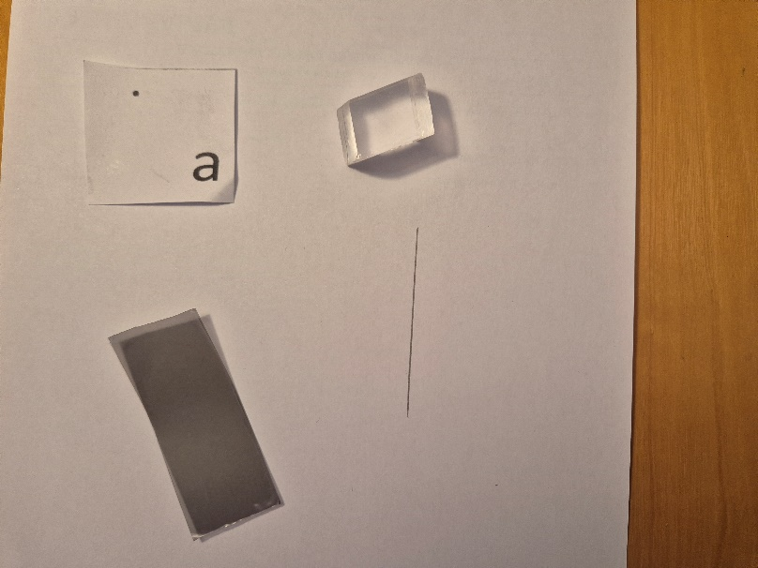
Fig.1: The material needed for the experiment

Description of the experiment
Put the crystal on top of the paper where you previously printed a dot and/or a symbol. In figure 2, the birefringent crystal was placed on the piece of paper so that the dot may be seen through it.
You should be able to spot two images of the dot or the symbol.

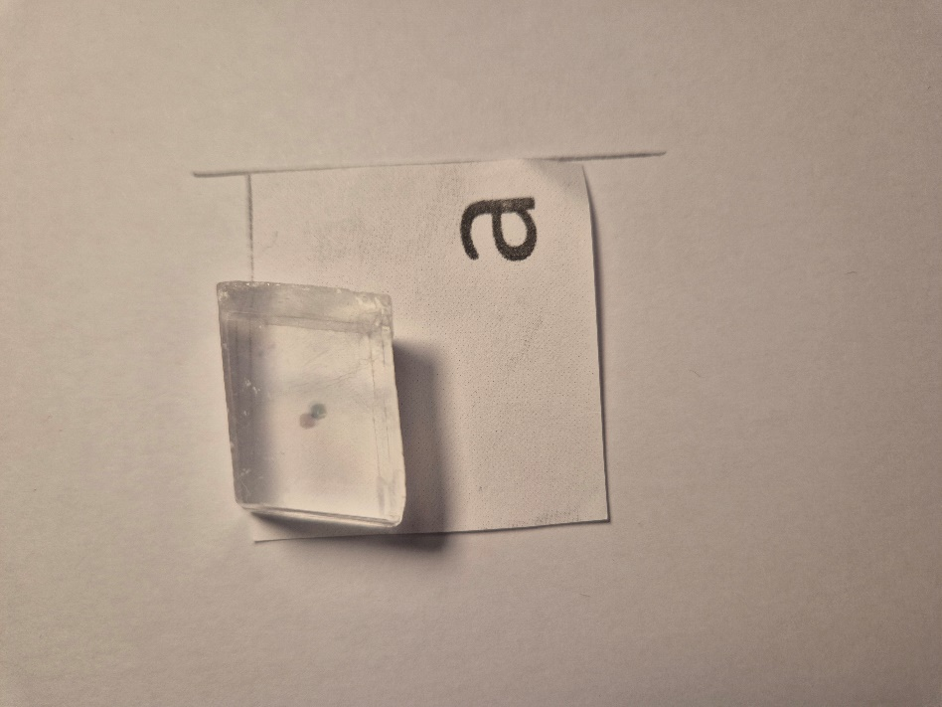
Fig. 2: Two images of the dot are visible.

Question 1: How can you explain what you see? How can you explain the two images?
Hint: search for the keywords “light polarisation” and “light refraction”.

Put the polarisation filter on top of the crystal and start rotating it around an axis perpendicular to its plane, until only one single point is visible.

Question 2: What happened to the second dot? What is the polarisation filter’s role? Explain.

(you can also put the polarisation filter underneath the crystal in the same direction as above).

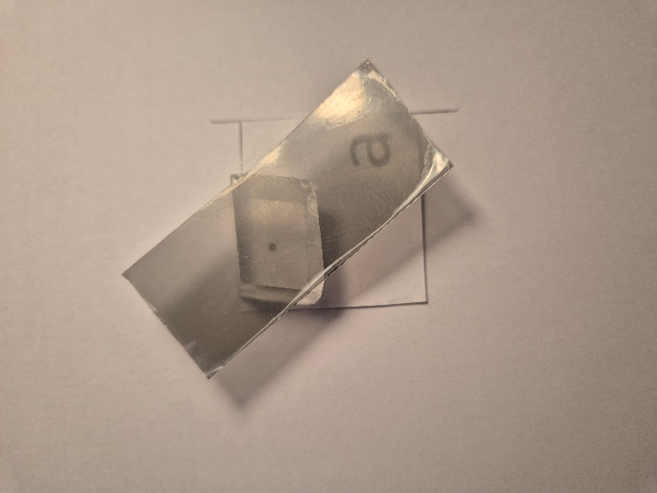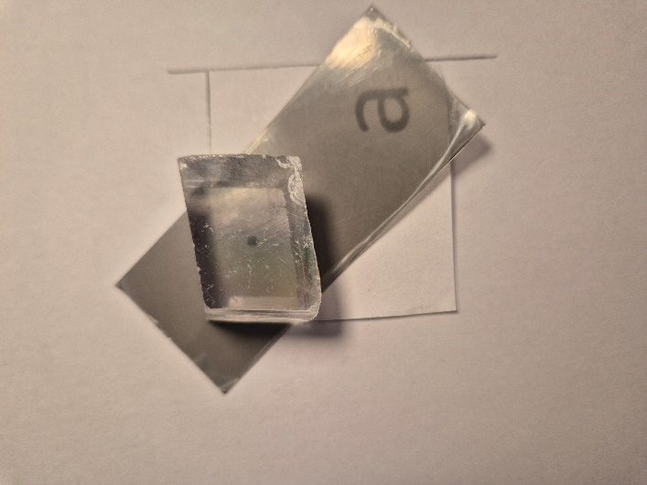
Fig. 3: Polarisation filter on top resp. below the crystal

Mark the orientation of the polarisation filter by drawing a line parallel to its long side with the pencil.
Now rotate the polarisation filter around the same axis as above, so that it is perpendicular to the mark.

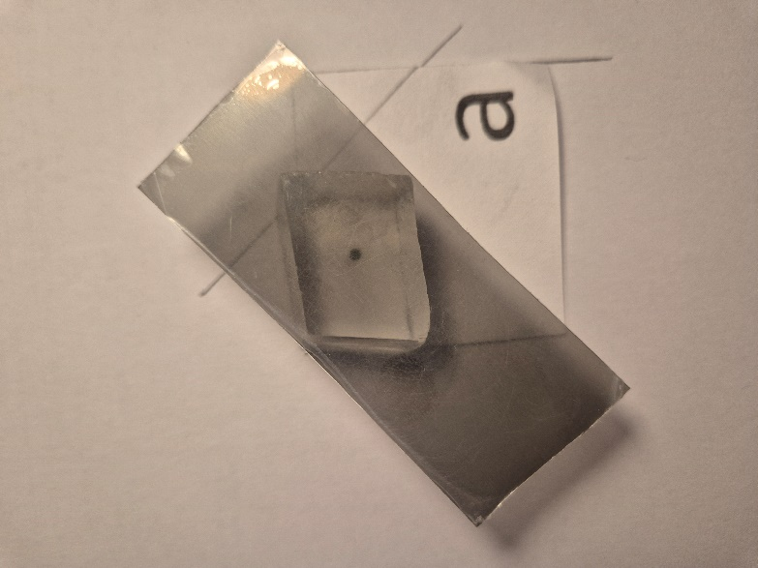
Fig. 4: The polarisation filter is perpendicular to its previous position.

Question 3: Describe what you see. Is the dot image the same as before? What did you notice while turning the polarisation filter? Explain.

Now turn the polarisation filter to an intermediate direction, on top or underneath the crystal.
Question 4: Are the dots now both visible?

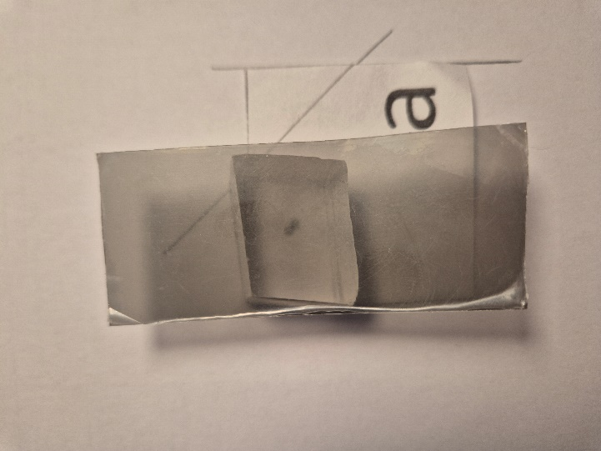
Fig. 5: The polarisation filter in an intermediate position

Summarise the conclusions you drew from this experiment, explaining what is happening to the light beam while passing through the crystal.

Outcome
This experiment demonstrates how light can be separated into two polarisation directions.

