Worksheet: The big question

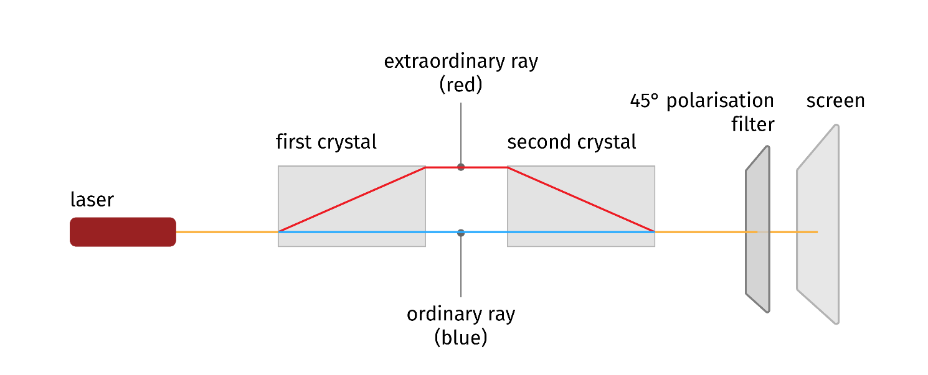
In the lab prepare the following experiment following the instructions below.

Material needed
- one lab laser
- goggles
- two calcite crystals
- a filter to analyse light polarisation (analyser)
- Screen (white paper sheet, a wall…)

Try it yourself
- Observe the laser using a polaroid. What can you see, by rotating the filter? Is there any particular angle at which light disappears? What is your conclusion?

- Now rotate the laser to observe no light when the filter is at 45° with the horizontal.
- Take one crystal and put it in front of the laser. Turn the laser on and project its light onto the screen. What will you observe? How many dots can you observe? Are the spots (if more than one) polarised? What direction?

- Search on the web about Calcite crystal to better understand the birefringence property and summarize here what you can find

- You already know that light can be explained in terms of photons. How can you explain the two beams you have just observed, thinking about the particle interpretation? What can you say about photon polarization?

- Now take a second crystal and put it close to the first one trying to find the right matching orientation to be able to observe one spot only below the two as in the picture below.
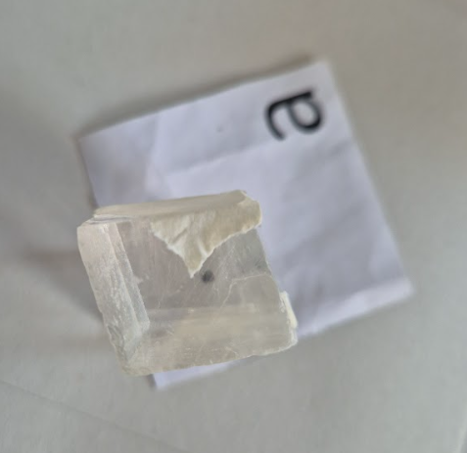
Once you found it, stick them together using a piece of tape.
- Now put them in front of the laser. What can you observe? How many dots can you observe? Is the beam intensity different, decreased or increased, with respect to the one you got without any crystal?
- Three students performed your same experiment and were really surprised on what they got. They then tried to explain what happened and came out with three different explanations:
- Photons go either one or the other path, even if they are fewer than before as they have passed through the filter (the polaroid)
- Photons go through both of the path, each one splitting in two parts
- Photons don’t go through any of the two paths, following a different trajectory

Write a paragraph where you logically explain why the three answers are all wrong.
This experiment is to show you that quantum physics needs a new kind of logic! Go back to your teacher for further explanation.

